|  |  |  |  |
| --- | --- | --- | --- |
| D:\Rinat\Rinat\доки\журнал\статьи\logo.jpg | Electrochemical behavior of rhodacarborane [3,3-(1',5'-COD)-8-PrNH=C(Et)NH-3,1,2-RhC2B9H10] in different organic solvents | | |
| Cite this: *INEOS OPEN*,  **2025**, *8 (1–3)*, XX–XX  DOI: 10.32931/ioXXXXx  *Received XX Month 20XX,*  *Accepted 5 December 2024*  http://ineosopen.org | | D. K. Semyonov,*a,b* E. V. Bogdanova,*a* and M. Yu. Stogniy\**a,b* | |
| a Nesmeyanov Institute of Organoelement Compounds, Russian Academy of Sciences, ul. Vavilova 28, str. 1, Moscow, 119334 Russia  b Lomonosov Institute of Fine Chemical Technologies, MIREA–Russian Technological University, pr. Vernadskogo 86, Moscow, 119571 Russia | |
| Abstract  The electron-transfer ability of 18-electron rhodacarborane [3,3-(1',5'-COD)-8-PrNH=C(Et)NH-3,1,2-RhC2B9H10] in acetonitrile and 1,2-dichloroethane solutions was ascertained by cyclic voltammetry. It was shown that in donor organic media the complex is irreversibly oxidized, whereas in dichloroethane solution the two consecutive one-electron oxidation processes take place. | | |  |
| **Key words:** rhodacarborane, half-sandwich complexes, cyclic voltammetry. | | | |

**Introduction**

Rhodacarboranes have been known since the mid-1970s [1, 2] and many of them have found applications as efficient catalyst precursors for homogeneous catalysis [3–5]. The investigation of electrochemical properties of metal complexes as well as the elucidation of correlations between their structures and redox characteristics are important tasks of modern chemistry, which can provide an understanding of the possibility of using these compounds in catalytic systems.

Despite the fact that the electrochemistry of carboranes and metal complexes based on them has been presented by a fairly wide range of studies [6–8], the electrochemistry of rhodium dicarbollide complexes has been studied scarcely [9–11].

In this work, we elucidated the electrochemical behavior of rhodium(I) complex [3,3-(1',5'-COD)-8-PrNH=C(Et)NH-3,1,2-RhC2B9H10] based on a *nido*-carborane derivative with amidine units in a side substituent. The investigations were carried out in different solvents, which showed a great dependence of the redox properties of the complex as well as the reversibility of electronic transitions of rhodium on the donor properties of a medium [12]. The results obtained are compared with those of a few related species known from the literature.

Results and discussion

The rhodacarborane to be studied [3,3-(1',5'-COD)-8-PrNH=C(Et)NH-3,1,2-RhC2B9H10] was prepared according to the previously described method through the reaction of *nido*-carboranyl amidine 10-PrNHC(Et)=HN-7,8-C2B9H11 [13] with dimeric [Rh(COD)Cl]2, where COD is 1,5-cyclooctadiene (Scheme 1) [14].

The electrochemical behavior of the resulting complex was studied in two organic solvents featuring different donor properties.



Scheme 1. Synthetic route to [3,3-(1',5'-COD)-8-PrNH=C(Et)NH-3,1,2-RhC2B9H10].

The cyclic voltammogram of the rhodacarborane in acetonitrile is shown in Fig. 1. According to the resulting voltammogram, the original neutral 18-electron rhodium(I) complex is prone to be irreversibly oxidized at *E*pa = +45 mV relative to Fc/Fc+.

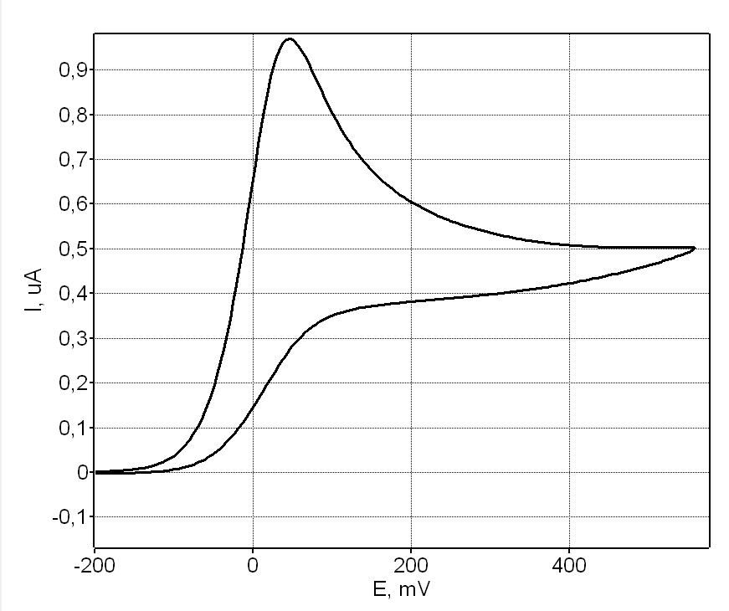

Figure 1. Cyclic voltammogram of [3,3-(1',5'-COD)-8-PrNH=C(Et)NH-3,1,2-RhC2B9H10] *vs* .Fc/Fc+ recorded in acetonitrile. Scan rate: 0.1 V·s–1. Sample concentration: *ca*. 3·10–3 M.

The irreversibility is due to the molecular reorganization of the original complex, which we believe consists in the replacement of the labile COD ligand with MeCN molecules and is visually accompanied by a change in the color of the complex from yellow to dark red. Moreover, the 11B NMR data revealed the disappearance of the signals of the original complex (acetone-*d*6, ppm: 4.9 (s), ‒12.5 (d), ‒16.1 (d), ‒23.7 (d), ‒26.7 (d)) and the appearance of a new set of signals (acetone-*d*6, ppm: 26.2 (s), –0.3 (d), –6.5 (d), –11.0 (d), –35.7 (d)) that presumably corresponds to an oxidized rhodium(III) complex, which is also supported by the diamagnetic nature of the complex. A similar process was previously observed in the case of other rhodacarboranes with labile ligands [3-(η6-arene)-4-Me2S-3,1,2-RhC2B9H10)]2+ [11].

In 1,2-dichloroethane, the cyclic voltammetric responses of [3,3-(1',5'-COD)-8-PrNH=C(Et)NH-3,1,2-RhC2B9H10] look completely different (Fig. 2).

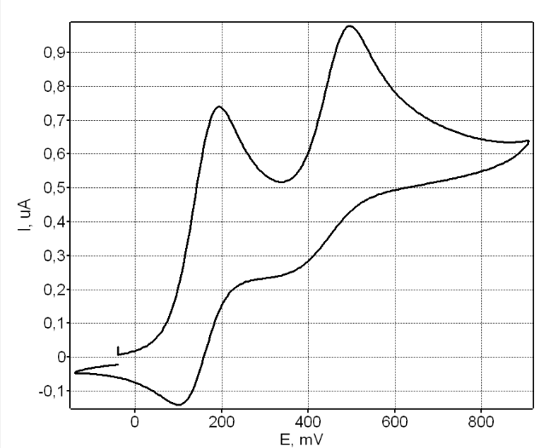

Figure 2. Cyclic voltammogram of [3,3-(1',5-COD)-8-PrNH=C(Et)NH-3,1,2-RhC2B9H10] *vs*. Fc/Fc+ recorded in 1,2-dichloroethane. Scan rate: 0.1 V·s–1. Sample concentration: *ca.* 3·10–3 M.

The voltammogram obtained demonstrates two peaks of sequential oxidation at *E*pa = +194 mV and *E*pa = +495 mV relative to Fc/Fc+, which obviously correspond to the sequential oxidation Rh(I)/Rh(II)/Rh(III). Each peak has a response peak at *E*pc = +103 mV (E1/2 = +149 mV) and *E*pc = +343 mV (E1/2 = +419 mV), respectively. An increase in the scanning rate leads only to slight changes in the shape of the voltammogram, which, along with the results obtained, presumably indicates the reversibility of the first transition, while the second transition is quasi-reversible.

The literature data on electrochemical properties of rhodium dicarbollide complexes are very scarce and are based exclusively on rhodium(III) complexes and their reduction to rhodium(I), which is irreversible [9–11].

Recently, the electrochemical study of a series of ferracarboranes was used to compare the donor effect of a dicarbollide ligand bearing amidine substituents with other dicarbollide ligands [15]. It would also be interesting to compare the electrochemical characteristics of a rhodium dicarbollide complex with other rhodium complexes containing the COD ligand. It is not surprising that 16-electron cationic rhodium complex [(COD)2Rh]+ [16] as well as the cationic complexes [(COD)Rh(LL)]+ with chelate azaheterocyclic ligands, such as 2,2'-bipyridine, 2,2'-bipyrazine, 1,10-phenanthroline, 1,2-bis(imino)acenaphthene, and their derivatives [17–20] exhibit a tendency to be reduced rather than oxidized. The same is true for the mixed-ligand complexes [(COD)RhCl(L)], where L is phenazine or quinoxaline, and [(COD)RhCl]2(pyrazine) [21]. Typically, these reductions are ligand-centered. The 16-electron complexes with chelating β-diketonato ligands [(RC(O)CHC(O)R')Rh(COD)] in acetonitrile, in addition to reduction, exhibit metal-centered two-electron oxidation [22, 23], while one-electron oxidation was observed in dichloromethane [24]. The 16-electron carbene complexes [(NHC)RhCl(COD)] undergo one-electron metal-centered oxidation in the range from 0.1 to 1.0 V depending on the ligand donor properties [25–27].

At the same time, the information available in the literature on the electrochemical properties of 18-electron complexes containing the [(COD)Rh]+ moiety and analogs of a dicarbollide ligand is rather scarce and contradictory. The ligand-centered reduction was also found for indenyl complex [(Ind)Rh(COD)], which is probably associated with the indenyl ring slippage [28]. Pentamethylcyclopentadienyl complex [Cp*Rh(COD)] was reported to be electrochemically inert in the range from –1.0 to –1.7 V [29]. Cyclopentadienyl complex [CpRh(COD)] exhibits reversible metal-centered one-electron oxidation at 0.05 V relative to Fc/Fc+ in dichloromethane, whereas related pentaphenylcyclopentadienyl complex [CpPhRh(COD)] undergoes two reversible successive one-electron oxidations at 0.09 and 0.72 V [30].

In the case of our complex, in which rhodium is coordinated with, on the one hand, the *nido*-carboranyl amidine ligand and, on the other hand, 1.5-cyclooctadiene, a shift in the rhodium oxidation potentials towards higher values is observed, which may indicate that the introduction of an iminium substituent at the 10-B position of the *nido*-carborane cage probably reduces its donor properties and makes the complex more stable to oxidation. At the same time, the lack of electrochemical data on similar rhodium complexes [31, 32] does not allow us to draw more accurate conclusions.

Experimental section

The electrochemical experiments were performed under an argon atmosphere at room temperature. Anhydrous dichloroethane 99.98% was purchased from Pallav Chemicals. Acetonitrile was purified by the standard method [33]. [NBu4][PF6] was used as a supporting electrolyte, 0.1 M in each case. Rhodacarborane [3,3-(1',5'-COD)-8-PrNH=C(Et)NH-3,1,2-RhC2B9H10] was prepared by the published procedure [14]. Cyclic voltammetry was performed with a SmartStat PS10 potentiostat-galvanostat in a three-electrode cell containing a platinum disk working electrode (*d* = 0.8 mm) and a platinum wire counter electrode. The potentials were measured relative to a silver pseudo-reference electrode (Ag wire in 0.01 M AgNO3 in MeCN with 0.1 M [NBu4][PF6]). The *E*1/2 Fc/Fc+ was used as a calibration reference standard.

**Conclusions**

The electrochemical study of rhodacarborane [3,3-(1',5'-COD)-8-PrNH=C(Et)NH-3,1,2-RhC2B9H10] revealed its different behavior in different organic media (acetonitrile *vs*. 1,2-dichloroethane). In a donor acetonitrile solution, the oxidation process is irreversible, whereas in dichloroethane, the complex undergoes two consecutive one-electron oxidation processes Rh(I)/Rh(II) and Rh(II)/Rh(III), first of which is reversible and the second one is quasi-reversible.

Acknowledgements

This work was supported by the Ministry of Science and Higher Education of the Russian Federation (agreement no. 075-00277-24-00).

The authors are grateful to Dr. E. I. Gutsul (INEOS RAS) and Prof. I. D. Grishin (UNN) for technical and information support.

Corresponding author

* E-mail: stogniy@ineos.ac.ru Tel: +7(903)532-6931  
(M. Yu. Stogniy).

References

1. E. L. Hoel, M. F. Hawthorne, *J. Am. Chem. Soc.*, **1973**, *95*, 2712–2713. DOI: 10.1021/ja00789a065

2. E. L. Hoel, M. F. Hawthorne, *J. Am. Chem. Soc.*, **1975**, *97*, 6388–6395. DOI: 10.1021/ja00855a017

3. F. Teixidor, R. Nuñez, M. A. Flores, A. Demonceau, C. Viñas, *J. Organomet. Chem.*, **2000**, *614*–*615*, 48–56. DOI: 10.1016/S0022-328X(00)00576-3

4. I. T. Chizhevsky, *Coord. Chem. Rev.*, **2007**, *251*, 1590–1619. DOI: 10.1016/j.ccr.2007.02.011

5. I. D. Grishin, D. F. Grishin, *Russ. Chem. Rev.*, **2008**, *77*, 633–648. DOI: 10.1070/RC2008v077n07ABEH003790

6. R. Núñez, M. Tarrés, A. Ferrer-Ugalde, F. F. de Biani, F. Teixidor, *Chem. Rev.*, **2016**, *116*, 14307–14378. DOI: 10.1021/acs.chemrev.6b00198

7. M. Corsini, F. F. de Biani, P. Zanello, *Coord. Chem. Rev.*, **2006**, *250*, 1351–1372. DOI: 10.1016/j.ccr.2005.12.009

8. I. D. Grishin, A. M. Zimina, A. A. Kaltenberg, *Physchem*, **2023**, *3*, 232–243. DOI: 10.3390/physchem3020016

9. N. El Murr, J. E. Sheats, W. E. Geiger Jr., J. D. L. Holloway, *Inorg. Chem.*, **1979**, *18*, 1443–1446. DOI: 10.1021/ic50196a007

10. D. A. Loginov, Z. A. Starikova, M. Corsini, P. Zanello, A. R. Kudinov, *J. Organomet. Chem.*, **2013**, *747*, 69–75. DOI: 10.1016/j.jorganchem.2012.12.021

11. M. Corsini, S. Losi, E. Grigiotti, F. Rossi, P. Zanello, A. R. Kudinov, D. A. Loginov, M. M. Vinogradov, Z. A. Starikova, *J. Solid State Electrochem.*, **2007**, *11*, 1643–1653. DOI: 10.1007/s10008-007-0324-2

12. V. Gutmann, *Coord. Chem. Rev.*, **1976**, *18*, 225–255. DOI: 10.1016/S0010-8545(00)82045-7

13. M. Yu. Stogniy, S. A. Erokhina, K. Yu. Suponitsky, A. A. Anisimov, I. A. Godovikov, I. B. Sivaev, V. I. Bregadze, *J. Organomet. Chem.*, **2020**, *909*, 121111. DOI: 10.1016/j.jorganchem.2020.121111

14. M. Yu. Stogniy, E. V. Bogdanova, S. A. Anufriev, I. B. Sivaev, *Russ. J. Inorg. Chem.*, **2022**, *67*, 1537–1544. DOI: 10.1134/S0036023622600848

15. M. Yu. Stogniy, S. A. Anufriev, E. V. Bogdanova, N. A. Gorodetskaya, A. A. Anisimov, K. Yu. Suponitsky, I. D. Grishin, I. B. Sivaev, *Dalton Trans.*, **2024**, *53*, 3363–3376. DOI: 10.1039/d3dt03549b

16. J. Orsini, W. E. Geiger, *J. Electroanal. Chem.*, **1995**, *380*, 83–90. DOI: 10.1016/0022-0728(94)03602-Y

17. E. Makrlík, J. Hanzlík, A. Camus, G. Mestroni, G. Zassinovich, *J. Organomet. Chem.*, **1977**, *142*, 95–103. DOI: 10.1016/S0022-328X(00)91820-5

18. W. A. Fordyce, K. H. Pool, G. A. Crosby, *Inorg. Chem.*, **1982**, *21*, 1027-1030. DOI: 10.1021/ic00133a031

19. L. De Cola, M. Ciano, F. Barigelletti, M. P. Garcia, L. A. Oro, *Inorg. Chim. Acta*, **1990**, *172*, 181–184. DOI: 10.1016/S0020-1693(00)80854-3

20. N. F. Romashev, A. L. Gushchin, I. S. Fomenko, P. A. Abramov, I. V. Mirzaeva, N. B. Kompan'kov, D. B. Kal'nyi, M. N. Sokolov, *Polyhedron*, **2019**, *173*, 114110. DOI: 10.1016/j.poly.2019.114110

21. A. R. Siedle, G. Filipovich, P. E. Toren, F. J. Palensky, E. Cook, R. A. Newmark, W. L. Stebbings, K. Melancon, H. E. Mishmash, *J. Organomet. Chem.*, **1983**, *246*, 83–93. DOI: 10.1016/S0022-328X(00)98654-6

22. J. Conradie, J. C. Swarts, *Dalton Trans.*, **2011**, *40*, 5844–5851. DOI: 10.1039/c1dt00013f

23. E. Fourie, *Inorg. Chim. Acta*, **2021**, *517*, 120209. DOI: 10.1016/j.ica.2020.120209

24. E. Fourie, J. C. Swarts, D. Lorcy, N. Bellec, *Inorg. Chem.*, **2010**, *49*, 952–959. DOI: 10.1021/ic901676e

25. S. Wolf, H. Plenio, *J. Organomet. Chem.*, **2009**, *694*, 1487–1492. DOI: 10.1016/j.jorganchem.2008.12.047

26. H. M. Peng, R. D. Webster, X. Li, *Organometallics*, **2008**, *27*, 4484–4493. DOI: 10.1021/om800404q

27. R. Thenarukandiyil, B. Maji, J. Choudhury, *Inorg. Chim. Acta*, **2019**, *487*, 419–423. DOI: 10.1016/j.ica.2019.01.002

28. C. Amatore, A. Ceccon, S. Santi, J. N. Verpeaux, *Chem. Eur. J.*, **1999**, *5*, 3357–3365. DOI: 10.1002/(SICI)1521-3765(19991105)5:11<3357::AID-CHEM3357>3.0.CO;2-E

29. R. Yamada, N. Iwasawa, J. Takaya, *Angew. Chem.*, *Int. Ed.*, **2019**, *58*, 17251–17254. DOI: 10.1002/anie.201910197

30. M. J. Shaw, W. E. Geiger, J. Hyde, C. White, *Organometallics*, **1998**, *17*, 5486–5491. DOI: 10.1021/om980788i

31. M. M. Vinogradov, Yu. V. Nelyubina, A. A. Pavlov, V. V. Novikov, N. V. Shvydkiy, A. R. Kudinov, *Organometallics*, **2017**, *36*, 791–800. DOI: 10.1021/acs.organomet.6b00858

32. S. V. Timofeev, O. B. Zhidkova, K. Yu. Suponitsky, A. A. Anisimov, I. B. Sivaev, H. Yan, V. I. Bregadze, *Inorg. Chim. Acta*, **2021**, *518*, 120243. DOI: 10.1016/j.ica.2020.120243

33. *Purification of Laboratory Chemicals*, *Sixth Ed*., Butterworth-Heinemann, Burlington, **2009**.

|  |  |
| --- | --- |
| This article is licensed under a Creative Commons Attribution-NonCommercial 4.0 International License. | [D:\Rinat\Rinat\доки\журнал\cc-by-nc.png](https://creativecommons.org/licenses/by/4.0/) |